Lab5 part 2

Yuichi Hamamoto

1. It throws an exception because at the end of sequence it misses temperature input which indicates one of sensor is broken

1. Current humidity and temperature

Test checks if the current temp and humid set to be 0 after reading (0, 0)

Test checks if the current temp and humid set to be 125 and 100 respectively after reading (125, 100)

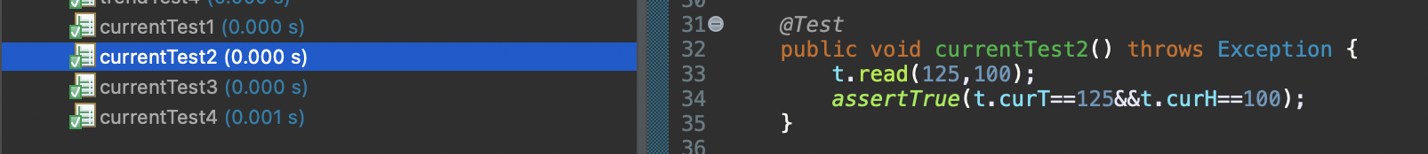

Test checks if it throws an exception when it receives invalid input (-1, -1)

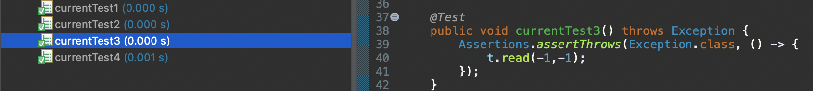

Test checks if it throws an exception when it receives invalid input (126, 100)

1. Max humidity and temperature

Test checks if the max temp and humid set to be 0 after reading (0, 0)

Test checks if the max temp and humid set to be 125 and 100 respectively after reading (0, 0), (125, 100)

Test checks if the max temp and humid set to be 125 and 100 respectively after reading (0, 0), (125, 100), (50, 50)

1. Min humidity and temperature

Test checks if the min temp and humid set to be 125 and 100 respectively after reading (125, 100)

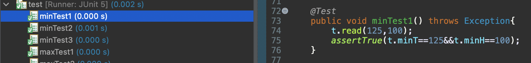

Test checks if the min temp and humid set to be 0 and 0 respectively after reading (125, 100), (0, 0)

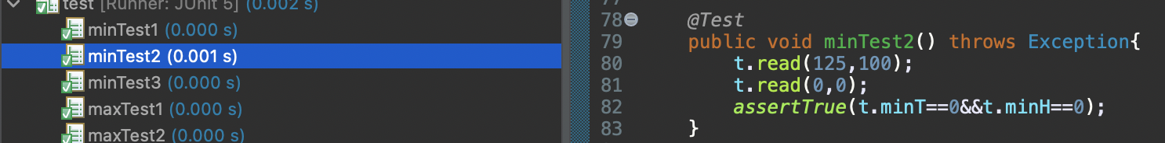

Test checks if the min temp and humid set to be 0 and 0 respectively after reading (125, 100), (0, 0), (50, 50)

1. Trends: Write separate test cases for each trend (up, stable, and down)

Test checks if trend of temp and humid is set to be N/A after reading (0, 0) as it does not have any previous data to compare and determine the trend.



Test checks if trend of temp and humid is set to be up and down respectively after reading (0, 1) and (1, 0).



Test checks if trend of temp and humid is set to be down and up respectively after reading (1, 0) and (0, 1).



Test checks if trend of temp and humid is set to be stable after reading (0, 1) and (1, 0).



iv) I did not have to refactor my code because my code was already refactored as I coded but I can imagine that it would be harder or more pain to test if it is not refactored as I would need to test more functions.

v) It might be harder to read the code, but I think it would be about the same.

vi) I personally prefer refactored one because I need to read and test fewer functions.co